The Old Ilminsterians Association

The Old Farmhouse,
24, Church Street,
Merriott,
Somerset,
TA16 5PS

Email: miketutcher@ymail.com

31st May 2014

Dear Old Ilminsterian,

It gives me great pleasure to provide details of our 2014 Re-union, to be held on Saturday 12th July.

11.30 am Church Service at St. Mary’s. All welcome.

13.00 pm Lunch at The Shrubbery Hotel. All welcome

6.30 pm AGM at The Shrubbery Hotel. Old Ilminsterians only

7.45 pm Annual Dinner. Old Ilminsterians only

This year during the afternoon, there will be an exhibition of old school photographs at the Shrubbery Hotel so why not drop in and take a look, even if you are unable to attend either the lunch or dinner.

For those who started in 1964 or 1954 that this year is your 50th or 60th anniversary so why not see who you can make contact with and come along. The re-union has been mentioned in the Chard and Ilminster News recently so hopefully there is a greater awareness of the event in the community and with prices held from last year, there’s no better time to get some new faces along!

This year a number of Old Ilminsterians have elected to receive this letter by email, rather than by post. If you would like to take this option in the future please indicate in the attached reply form or drop me an email with your address.

Finally, as every year, I would again like to express our gratitude to those who so generously give money in support of the Association. With no annual subscription and a desire to keep the Re-union costs to a minimum, these donations are crucial to our financial health.

I look forward to seeing as many of you as possible on the 12th.

Regards,

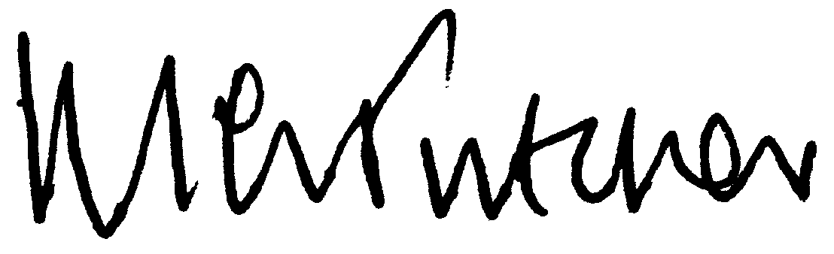

Hon Sec.

Name | First Name
Name | Surname
Address (change if necessary)
I would like to receive the annual letter by email in future | Email address
Years at school | 19__ to 19__

Event | No of People | Names | Cost
Lunch @ £14.50 each |  |  | £
Annual Dinner @ £19.50 each |  |  | £
Donation |  |  | £
Total |  |  | £
Cheques to “The Old Ilminsterians Association”

Visit our website at: http://www.oldilminsterians.org.uk/. Please return no later than 30th June 2014

