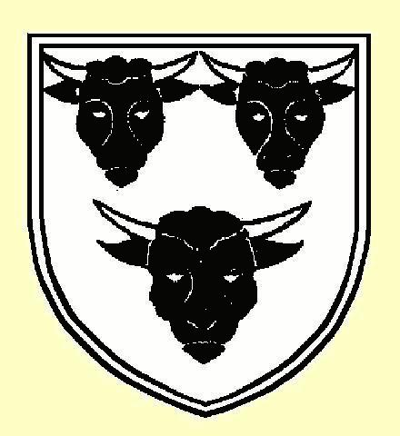
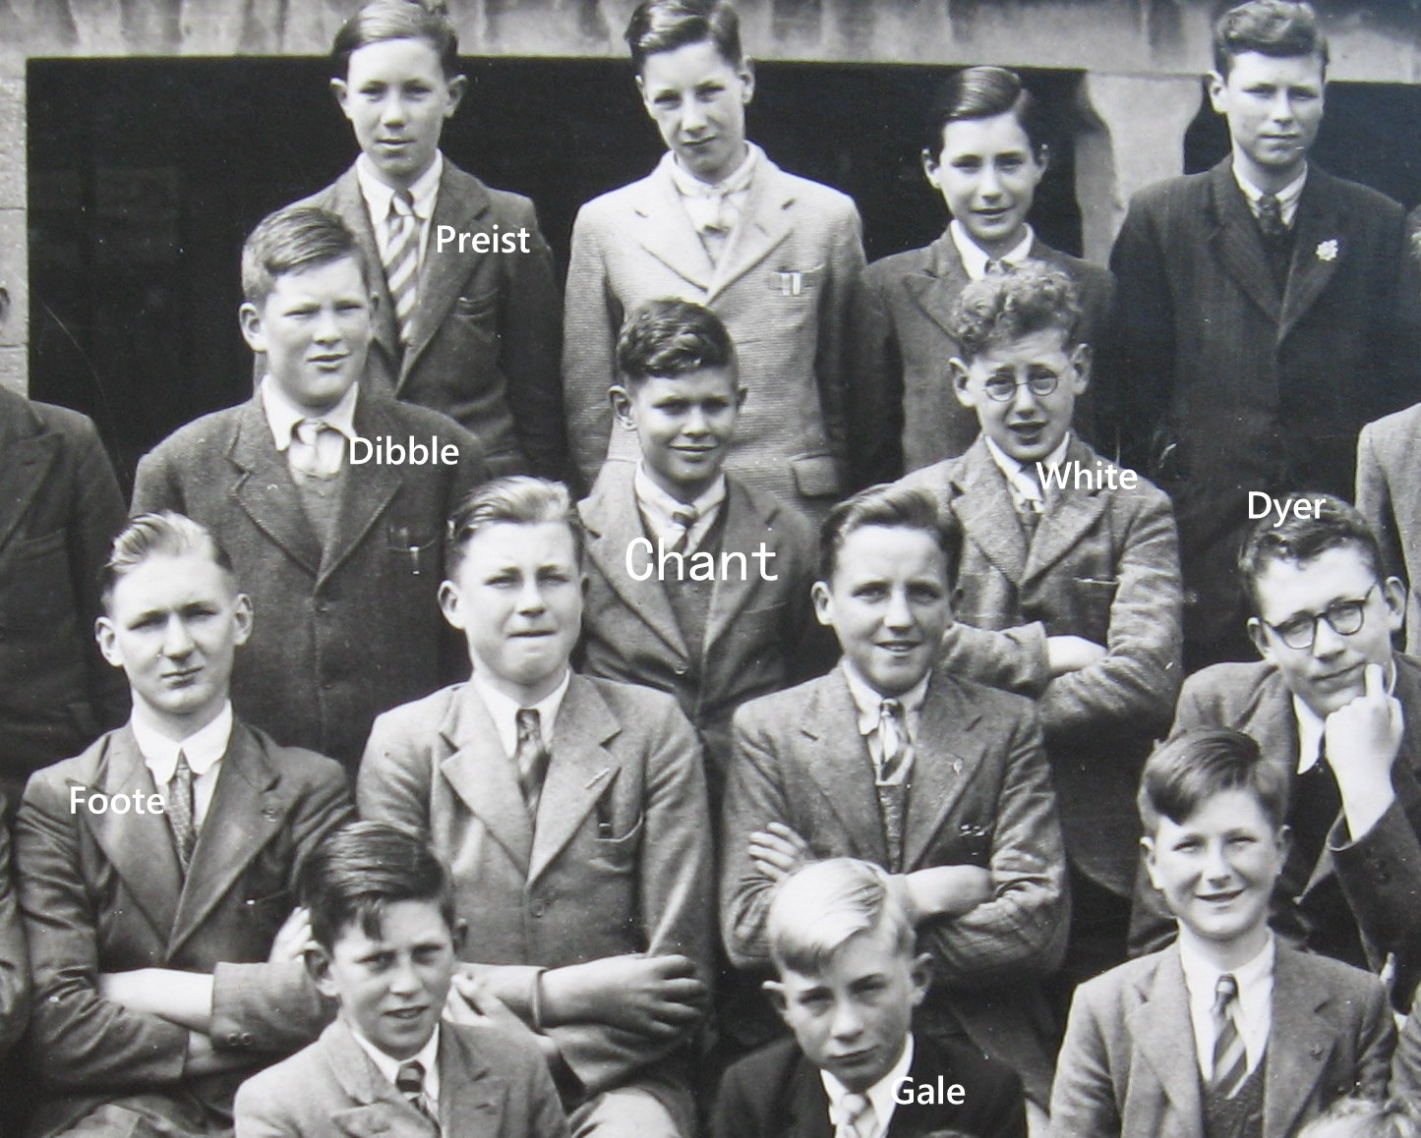
It’s Coming Up Now - 70years ago !
(Some recollections by John Chant - Summer 2011)
These recollections may be a bit sketchy and not entirely accurate because - in September, it will be 70 years since I started at Ilminster Grammar School. That’s me – in the middle of this 1947 photo.

So,- it is 1941 - during the war - and those masters who had been called up had been replaced by some brought in from retirement. I remember Mr Martin who taught Science and Mr Read who, being too old for the forces, was Form I master and taught Woodwork. The workshop was adjacent to the swimming pool in the Upper5/Lower5 Block. He found that a length of 1/4inch dowelling was very useful in keeping the class orderly – for there were no chair backs to the long line of desks! However, he was a kind man - if one kept quiet - and he gave me two chisels as prizes for being first in class. I still use them to this day. When I started at IGS I hadn't a clue what 'Houses' were until I was put in Wadham. At the first meeting Mr Baker a strict teacher (of Geography & French?) said that the red badges cost 2d. I shouted out that I had got 4d. That brought the house down! In the end-of-term report he said that I should be less precocious?
Eventually I was transferred into Hanning following a reorganisation after masters returned from the forces. Ilminster boys were grouped into Wadham, Chard into Walrond and the South Petherton area into Hanning. The Housemasters were Mr Maher, Mr Carpenter and Mr Kimber respectively.
One early event in my memory of school was a Cadet Corp exercise involving the younger boys being sent into the Herne Hill area to hide and - act as 'Savages'. The cadets then swept the area shooting the savages. There was much clicking of rifle bolts and noise of the shots being fired. My hiding place was near the old canal.
Another wartime memory was of taking a gas mask to school. We also had evacuees come to IGS and there was a lot of aircraft activity near the school: lots of Dakotas towing gliders and then releasing them to land at Merrifield, the Ilton aerodrome.
Our Cadet Corps was attached to the Somerset Light Infantry and commanded by Major Davy & Captain Lang after they had returned from duty (the former in France and Burmah). We practised rifle shooting in a 25yd 'skittle alley' range in Ditton Street. One year our team won the Napper Shield. This was using 0.22 rifles. Apart from the competition rifles, we had in the armoury three Boer war carbines (single shot) - used as starting gun on sports day! There was a good selection of 0.303 rifles - some with magazine cutoffs, one or more Sten guns and a Bren (LMG). I can also remember a cutaway hand grenade. The cadets enabled me to go on an Electrical Engineering course for a fortnight at the REME Armament & Electrical Trade School at Bordon, Hants in April '50. That gained me a ‘Certificate T’.
I delayed National Service until I had finished my Engineering Apprenticeship but, when I was sent to RAF Yatesbury No.2 Radio School for Air Radar training, I found that the Corporal in charge of our billet was Swan, a younger boy at IGS when I was a Prefect. Luckily we had no problems at school otherwise life could have been difficult for me. As a matter of interest Mr Maher was also at Yatesbury in wartime and used to take part in shows at 'The Little Theatre' in the camp.
Our Christmas concerts usually featured the choir singing selections from HMS Pinafore. The Drama Society put on a play in which I was the top half of a monster and then Polly Perkins in 'The monkey's paw'. Mr Maher would come as a comedian, one joke was “he knew when he was getting near to Ilminster as the same cow had walked past the train three times”. Another skit was Maddock & X walking onto stage with their right arms up - then halting and saying “Hey mate we've forgotten the ladder”. Victor Dibble sang 'Drake is in his hammock'.
Was it in English or did we have ‘general studies’, but I remember a mock election. I think Vernon Carpenter was standing as a Conservative and was declared elected. Some good political debating ensued from Blake & Y (on Blake's right in the photos at end). Included in the English Lit syllabus was Shakespeare's Henry V. My father took me to see the film in Yeovil – but - the school took us to Taunton to see it anyway – then, a travelling cinema came to the school to show it. I failed English Lit !
After School Cert, another memorable time was in 1948 was when all boys with swimming colours had the use of the swimming pool for about three weeks. The weather was perfect, but the pool - in early days it was a soupy green with - chlamy demoni ? We could only ever see a few inches, which made collecting tin plates from the bottom on sports day difficult. When Somerset Education took over sackfulls of chemicals were poured in - making it a soupy blue – was that healthier ?
There was a coach trip to Weymouth and there were the ‘clubs’. No, I mean like the Chess Society in which I won the competition one year, managing to beat Tony Dyer who later became Radio's Brain of Britain. His family owned Dyers shop. Mr Cousins was the ‘chess man’.
Another recollection, of 1950, was a trip to HMS Heron, the RNAS at Yeovilton by a party of cadets. While there we all in pairs had a flight in an RAF Oxford? twin engine plane. We flew firstly over Yeovil at about 1000ft then IGS and finally over my home village of South Petherton and Parrett Works. While over our school we saw Mr Parker our caretaker mowing the cricket ground. It was probably the first flight for all of us - never to be forgotten!
While in the 6th form, I built a wavemeter to test the transmitter output of Mr Sawyer’s transmitter G3DTB and had a keen interest as a SW listener on 3.5Mhz. In addition to the Radio Club, Mr Sawyer started the Bee Club. In this we could buy shares. The dividend was to take home a pot of honey.
In last years of the School I noticed that masters are referred to by their Christian names – how things have changed!
yours formally, Chant, year of ’41 :>)
What another ink-blot boy ?

Webmaster’s note : John also provided several sections of the 1947 photo – with names marked over faces. If you are interested – make contact.

THE OLD ILMINSTERIANS ASSOCIATION www.BTinternet.com/~old.ilminsterians/

