The Old Ilminsterians Association

The Old Farmhouse,
24, Church Street,
Merriott,
Somerset, TA16 5PS

26th May 2009
Dear Mr Old Ilminsterian,

Once again it is my pleasure to bring you details of our 2009 Re-union, to be held on Saturday 11th July.

11.30am Church Service at St. Mary’s. All welcome.

12.30pm Lunch at The Shrubbery Hotel. All welcome

6.30pm AGM at The Shrubbery Hotel. Old Ilminsterians only

7.30pm Annual Dinner. Old Ilminsterians only

This year, I am delighted to inform you that our guest speaker at the dinner will be the local MP, Mr. David Laws. David has a double first in Economics from Cambridge University and was Managing Director at Barclays Bank before joining the Liberal Democrats as the Parliamentary Party’s Economic Advisor in 1994, writing their 1994 and 1995 alternative Budgets. In 2001, he succeeded Paddy Ashdown as MP for the Yeovil constituency and was appointed Shadow Chief Secretary to the Treasury in 2002. He was re-elected, with a much increased majority in 2005, taking 51% of the vote and appointed Shadow Secretary of State for Work and Pensions. In 2007 he was appointed Shadow Secretary of State for Children, Schools and Families. David list of interests includes reading, running, athletics and rugby, but he is a popular and hard working MP who must find it difficult to find time for any of these. He will, I am sure, provide some interesting views on local education and other topics.

The notice convening the OIA Charitable Association AGM can be found over the page. The OIA AGM will follow.

Once again on behalf of us all, I would like express our gratitude to those of you who so generously give monies in support of the Association each year. With no annual subscription and a desire to keep the Re-union costs to a minimum, these donations are important to our financial health.

Finally, can I remind those who started or left in 1969 and 1959, in particular, that this year is your 40th or 50th anniversary and as such perhaps a good excuse to get together. I look forward to seeing as many of you as possible on the 11th.

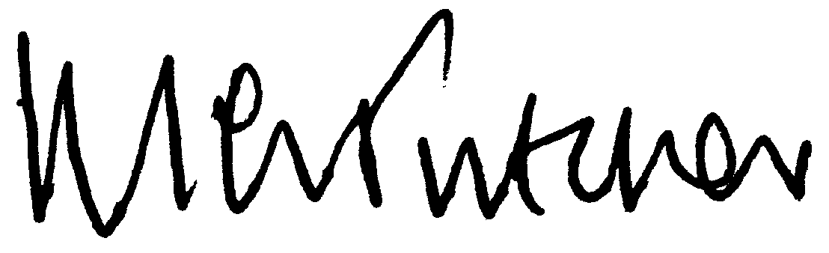

Mike Tutcher
Hon. Sec.
OLD ILMINSTERIANS CHARITABLE ASSOCIATION

I hereby give notice that the 4th Annual General meeting of the Old Ilminsterians Charitable Association will be held at the Best Western Shrubbery Hotel, Ilminster on Saturday 11th July 2009 at 6.30pm.

Please note that the present Trustees and Officers of the Association will retire with effect from the conclusion of the AGM, but may seek re-election. The Charity must receive any nomination for these positions prior to the meeting and which a member, entitled to vote, at the meeting must sign. The person who is to be proposed, to show his or her willingness to be appointed, must also sign the nomination.

A G E N D A

1. Apologies
2. To confirm the extracts of the minutes of the Old Ilminsterians
Association held on 12th July 2008.

3. Report from the Chairman and Trustees.
4. Report from the Treasurer of the Charitable Association.
5. Election of Officers and Trustees.
6. Any other business.

Visit our website at: www.btinternet.com/~old.ilminsterians

Please return to the Secretary no later than 26th June 2009

Name | First Name
Name | Surname
Address (change if necessary)
e-mail address
Years at school
Event | No of People | Names | Cost
Lunch @ £13 each |  |  | £
Annual Dinner @ £18 each |  |  | £
Donation |  |  | £
Total |  |  | £
Cheques to “The Old Ilminsterians Association” .………………………………………………………………………………………………………

