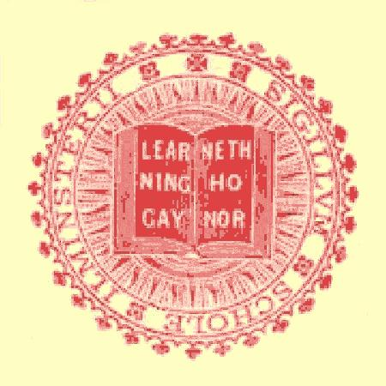
Ilminster Grammar School Clubs & Activities :

– Expeditions

The 1963 France visit…. Some recollections from Steve Sawyer

To write a comprehensive account of this trip is well beyond my powers of memory or Eng Lit. However, it did provide a powerful stimulus to my appreciation of French culture, culminating in my being resident here in La France Profonde, a councillor yet in our commune (pop. 193, any friend of the mayor’s easily elected – and we get on very well)

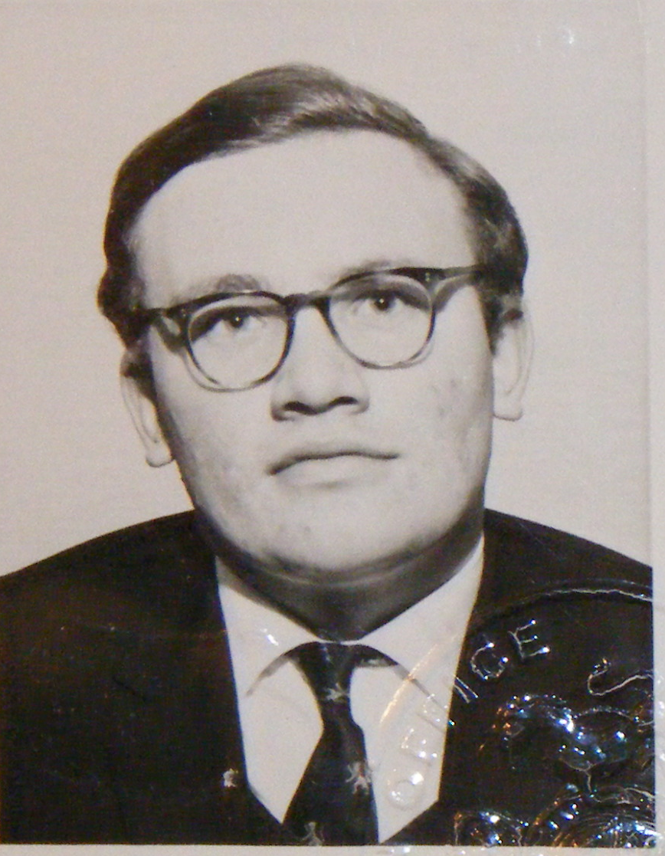
So – a few memories of the “Ah yes, I remember it well” variety, which I hope someone can augment and correct. We travelled on a group passport. I seem to remember posing in a corduroy windcheater for the photo, but a year later I was off on my own passport – for those with a long memory this is the 1964 passport pic and I suppose must be rather what I looked like at the time.

I remember Tom Smith working hard for his PSV and an air of simple pride in the wearing of the red and white badge on the bus. And I remember his early advice – “Gentlemen, I shall be smoking my pipe. You may smoke if you wish” – a permission which turned the inside of the coach into a fair representation of a Northumberland kipper-smoking shed in seconds.

And was not this the occasion when arriving in Versailles the lord Maher (who had had an unfortunate prang en route) parked his car at night - impossibly - between what turned out to be two enormous trees? And did we not have to manhandle it out?

Then there was breakfast. They gave us some extraordinary whitish compound, which tasted of sour milk into which they poured jam. If anyone had told us then that within three or four years we would be paying good money to buy cardboard tubes of the stuff marketed as “Ski” yoghurt our disdain would have known no bounds.

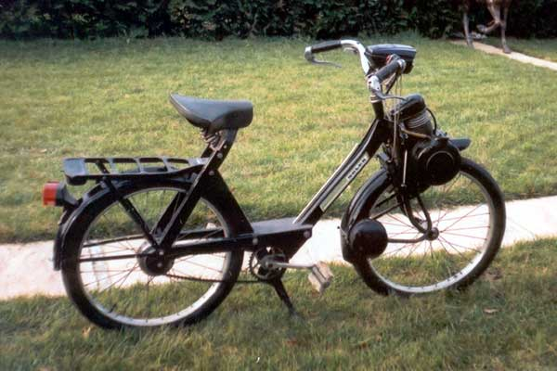
Do you recall the French motorised bikes? Hundreds of them bouncing over the cobbles around Versailles carrying passengers and a great variety of luggage; bread, of course, but also crates of vegetables, live chickens… and the rest.
Greatly diverted, we asked Tom for a translation of “Get off and milk it!”, which I recall to this day as “Descendez pour le traire”, although it might be slightly more insulting as “Descends….”. We only shouted it at a safe distance anyway.

Oddly, the only other phrase I remember learning on that visit was “Tout le monde est sur le balcon” (or “il y a du monde au balcon”) which had better be left untranslated. Such is the value of these trips for “A” level students!

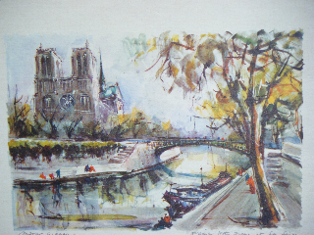
I wonder how much we paid for pictures like this along the Quais, no doubt imagining we were real art critics!

We did get to see the hall of mirrors at Versailles, wherein a large lady from the USA was heard to observe very loudly, “Wilmur! There’s hot air comin’ out of here!” - which, although true, was not really the point of the visit. We also found a baker’s in Versailles between the school we stayed in and the railway station which, in the golden memory of youth, sold bread like nothing we had ever tasted before, or indeed since. If one could only find it again it might offer some hints to our current boulangère.

Then there are personal memories. Of the Flea Market in Paris, for example, where I became confused – not to say deranged – by the recent revaluation of the Franc and spent almost every last centime on a small phial of Jasmine perfume for my mother, which probably smelled ghastly and which I do not recall her ever wearing. But it contributed to a mounting gambling-debt from games of pontoon played – well, played almost anywhere, really. I probably still owe someone several old shillings. (Please do not try to reclaim it!). And on our last morning in Paris, I can almost see Tom now asking if a café could provide us with “Croissants et café dans des grands bols”, accompanied by a suggestive gesture as of tenderly caressing such a bowl. It could, it did, and for years I loved the sensation of such rich coffee/chicory/milk mixtures as were served every morning, even if now my coffee is served black.

But perhaps the most important memory – or the most important reality – was of being treated much more like adults than had ever previously been the case. We did not have to smoke our cigarettes furtively, and with impunity we could go into a café and ask for “Un verre de vin blanc sec”, which seemed like the most sophisticated thing that one could possibly do. They were simpler days, and such trips were still great adventures, where my daughter, herself teaching French, now sees them as an annual chore. I went on to stay “en famille”, and thus to scrape through an “A” level pass I probably did not deserve, and to pass on a love of France to wife and children. So thanks, Tom, Bruce and the rest for all the effort and planning. There will be others as well as me who think it was well worth it!

Steve Sawyer (’57 – ‘64)

THE OLD ILMINSTERIANS ASSOCIATION www.BTinternet.com/~old.ilminsterians/

