THE ILMINSTERIAN - VOL XXIX No. 47

AUTUMN TERM, 1936, SPRING AND SUMMER TERMS, 1937.
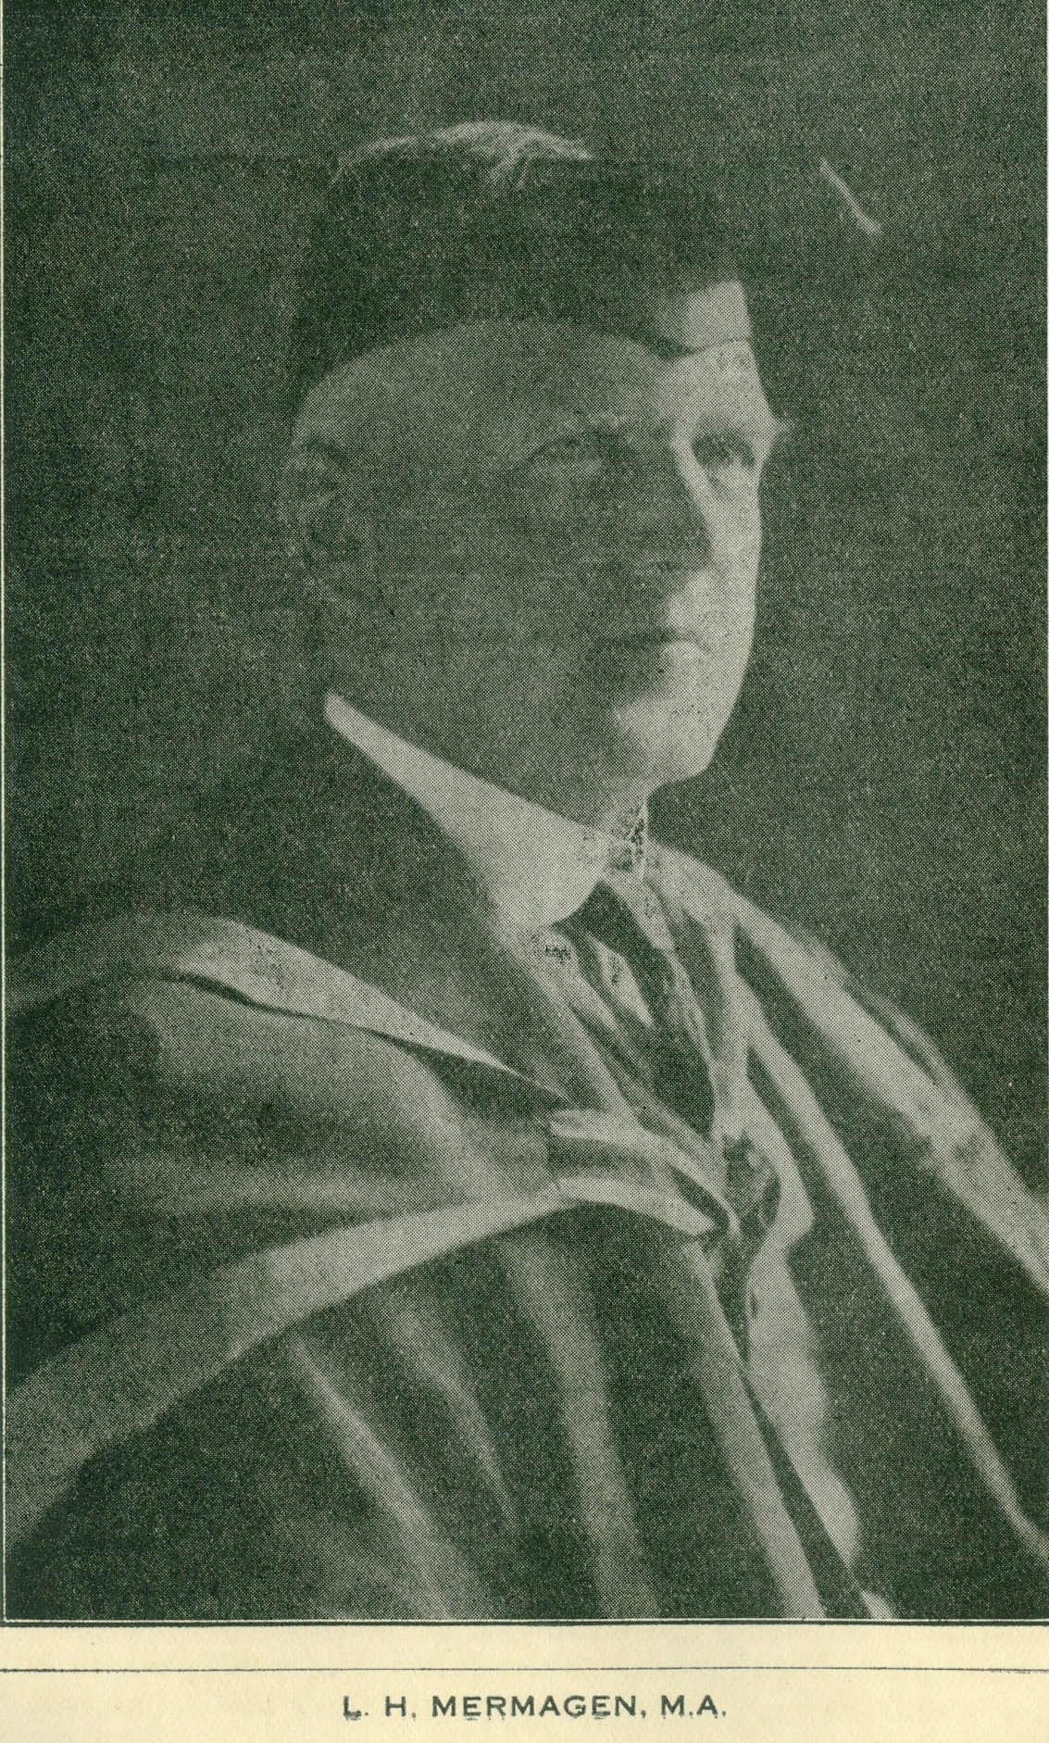
EDITORIAL.
This year, for the first time, I.G.S. has an independent magazine. From now the magazines of the Boys' and Girls' Schools are to be separate. It has therefore been possible to reduce the price of the magazines to ninepence. The photograph on the opposite page is a reminder of an event that is still fresh in our minds. A headmasters retirement is a major event in the life of a school at any time, but when it terminates a headmastership of a quarter of a century it gives an opportunity of recalling countless changes and of realising what a school can owe to its Head. Mr. Mermagen's pupils, present and past, and his staff testified to their appreciation of his worth as a Head last July.
The "Ilminsterian" takes the opportunity of wishing him a happy retirement at Taunton, only a few miles from his wide circle of friends in and around Ilminster. An appreciation of Mr. Mermagen's work as Head of I.G.S. appears on page 4.
In Mr. Mermagen's place we welcome Mr. R. T. Graham, M.A. In the short time he has been here Mr. Graham has made many friends outside the school but, more important, he has gained the genuine respect and affection of his boys and his staff. Some changes inevitably accompany a change of headmaster. Mr. Graham's changes have been popular all round. Thanks to him the school Cadet Corps has been revived, and promises to be as vigorous as it was some years ago. Other changes, though less striking, have been equally beneficial. If Mr. Graham were to leave us tomorrow he would leave a lasting memorial in the shape of the new shower-baths! Last July we said goodbye, together with Mr. Mermagen, to Mr. Tothill. He had been at the school for ten years and he did not leave an easy place to fill. As a teacher he worked with quiet efficiency; anything in the nature of "fireworks" would have been detestable to him. His colleagues miss his unfailing good spirits and his dry humour. Both they and his old pupils wish him a happy retirement.
We welcome Mr. G. Davey, B.A., as French master. By now Mr. Davey is so completely one of us that the welcome seems superfluous. As a sportsman (in school games and with Taunton 1st Rugby XV.), as a teacher, as O.C. of the school Cadet Corps, and last but not least as a dramatic producer struggling with the most refractory group of actors any producer ever faced, Mr. Davey has made his mark.
Last term we had with us Mr. E. W. Young, B.A. Although he knew his stay in Ilminster was to be a short one, Mr. Young threw himself into the life of the school and of the town. We were sorry to lose him, but glad to hear of his getting a post at that famous school, Oundle, and we wish him every success.
It only remains to add that the life of the school, its work and play, are still healthy. Masters come and masters go, but the school goes on - if not for ever, at least with no symptoms of imminent decay.
Transcriber’s Note: a ‘J.C.B.Kimber’ signed as audited and correct the OIA Accounts for 1936
The Balance Sheet totals were £30 1s 10½p, with £3 19s 10p ‘in hand’
OLD BOYS' EDITORIAL.
Undoubtedly many old boys are and have been abusing the belated appearance of this number of the "Ilminsterian", but they may be assured that their magazine editor finds true cause for gratitude therein for various reasons. First it must be explained that the sole reason for the three months' delay in printing the magazine is that now and henceforward our School and IGGS will issue entirely independent and separate magazines. This decision, arrived at late in the recent Christmas Term, has indirectly lightened my burden for, in accordance with the wish expressed by the 1938 Annual General Meeting the Hon. Secretary's report on the year 1937 is being incorporated in our section of the magazine. Thus I find myself relieved of the necessity of surveying the activities of the Association during the past year: the now-retired Hon. Secretary has in his report unwittingly and adequately done it for me.
There is little to be added to that report which is printed below with the sentiments of which I wish to associate myself. Particularly would I emphasize the need for Old Bovs to take a more active interest in their Association. It is not sufficient that members should pay their subscription annually and rest content; we shall never have a live association unless many more old boys put away their lethargy and attend, and encourage others to attend, the different functions which are arranged during the year. It is, in- deed, comforting to know that there are the faithful few who never fail to support, but the absence of so many who could be and should be there makes the work of the officers and committee much more onerous. In addition, nothing is so disheartening as to find meagre support for a function among those for whom it is arranged. Actually, our activities are far more varied and numerous than are those carried on by the majority o£ Old Boys' Associations: is that fact fully realised by Old Ilminsterians?
An effort is now to be made to establish a real and memorable Annual Old Boys' Day. On Saturday, July 23rd, it is hoped that the following day's programme will be carried through:-
a short service in the church at about 11 a.m.; an all-dav cricket match with the alternative of a tennis tournament; a smoking concert or some such affair in the evening.
Members will be advised of the full details when the Summer comes. Meanwhile, I commend the Day to old boys and appeal for their full and unstinted support. The new Hon. Secretary, F. W. Follett, o£ Station Road, Ilminster, or myself will be delighted to know of those who intend making the pilgrimage to their old school for the event. The presence of any who live at a distance and who, therefore, are seldom seen at Ilminster, is especially desired. It is suggested to such that here is a ready-made excuse for spending a week-end with a contemporary who is living in or near Ilminster. There are several who would be willing hosts. Remember, old boys, that in 1949 we shall be celebrating the fourth centenary of our School's foundation. You can begin to prepare for that celebration by putting in an appearance at this year's Re-union Day, and by doing your best during the years that intervene to make that Re-Union Day a real event by 1949. As our Association grows older, I become more firmly convinced that it is only the personal touch of one old boy with another which will ensure the growth and firm establishment of the O.B.A. It is becoming more and more clear, too, that correspondence consisting of circulars, reminders, etc. is largely a waste. Our membership should be at least double the present number: it could easily be done with the co-operation and help of those who are already members.
F.S.C

Continued on next page

THE OLD BOYS' ASSOCIATION - Subscribers for 1937.

LIFE MEMBERS
E. H. Bancroft
F. W. J. Britten
F. A. Barber
A. C. Deverell
R. Hann
W. F. Hann
R. A. Holden
G. N. Love
L. H. Mermagen
I. J. Morgan
H. W. Poole
E. H. Scott
D. J. Vaux
H. M. M. Wright
B. G. Wyatt
N. M. Wainwright

YEARLY SUBSCRIBERS
*A. J. Appleton
*G. C: Abbott
J. L. S. Babb
F. E. Barnes
*L. S. Barnes
R. W. Bellringer
I. Buller
R. W. Burrough
*L. J. Burton
F. S. Carpenter
S. P. Chapman
H. F. Coles
H. F. Clarke
*C. H. Cleal
G. L. Corley
S. Crawford
C. Creed
T. H. F. Creed
J. E. M. Crouch
F. R. Darby
S. R. Darby
*H. J. Denman
W. J. Doble
H. C. F. Dowell
D. N. Dunlop
*E. G. Dyer
R. .J. Dyer
R. E. Evans
*F. W. Follett
W. A. Gale
M. E. Goodland
B. W. Goodland
D. F. W. Hake
T. Handel
*C. F. Hocken
*J. Hocken
M. R. Hocken
*F. L. Harding
J. H. Hellier
C. V. Hopkins
W. F. Hosegood
A. L. Horsey
P. C. J. Hoyal
H. W. Hutchings
T. L. Hunter
L. S. J. Jacobs
*W. J. Jeffery
A. E. Kitch
A. L. Larcombe
J. T. S. Long
K. J. Long
R. C. G. Loveridge
R. Lucas
*E. V. Masters
C. E. Marks
H. J. Marks
H. W. Mermagen
J. H. F. Mermagen
P. H. F. Mermagen
*R. L. Martin
*D. J. Miles
*S. K. Ockenden
I. J. A. Orchard
*W. F. D. Palmer
W. G. Palmer
W. A. Plaster
E. B. W. Prew
C. H. Puckett
*A. J. B. Paull
A. C. Pym
E. J. Rails
A. F. Rice
*J. W. Rice
*P. L. Rice
*B. W. Reynolds
H. Rosewell
J. T. Rutter
E. J. Rutter
R. W. Savidge
*E. G. L. Scott
J. B. Shutler
H. Shire
S. W. Slade
W. J. Stoodley
C. J. L. Sweeting
*D. Turner
J. C. Turner
E. Turvill
W. Turvill
O. W. Warne
*G. Welch
K. G. Whaites
J. F. White
L. J. White
F. W. Wood
C. H. Wyatt.
E. A. Wainwright

* Denotes New Member
Transcribed MWP/2018

