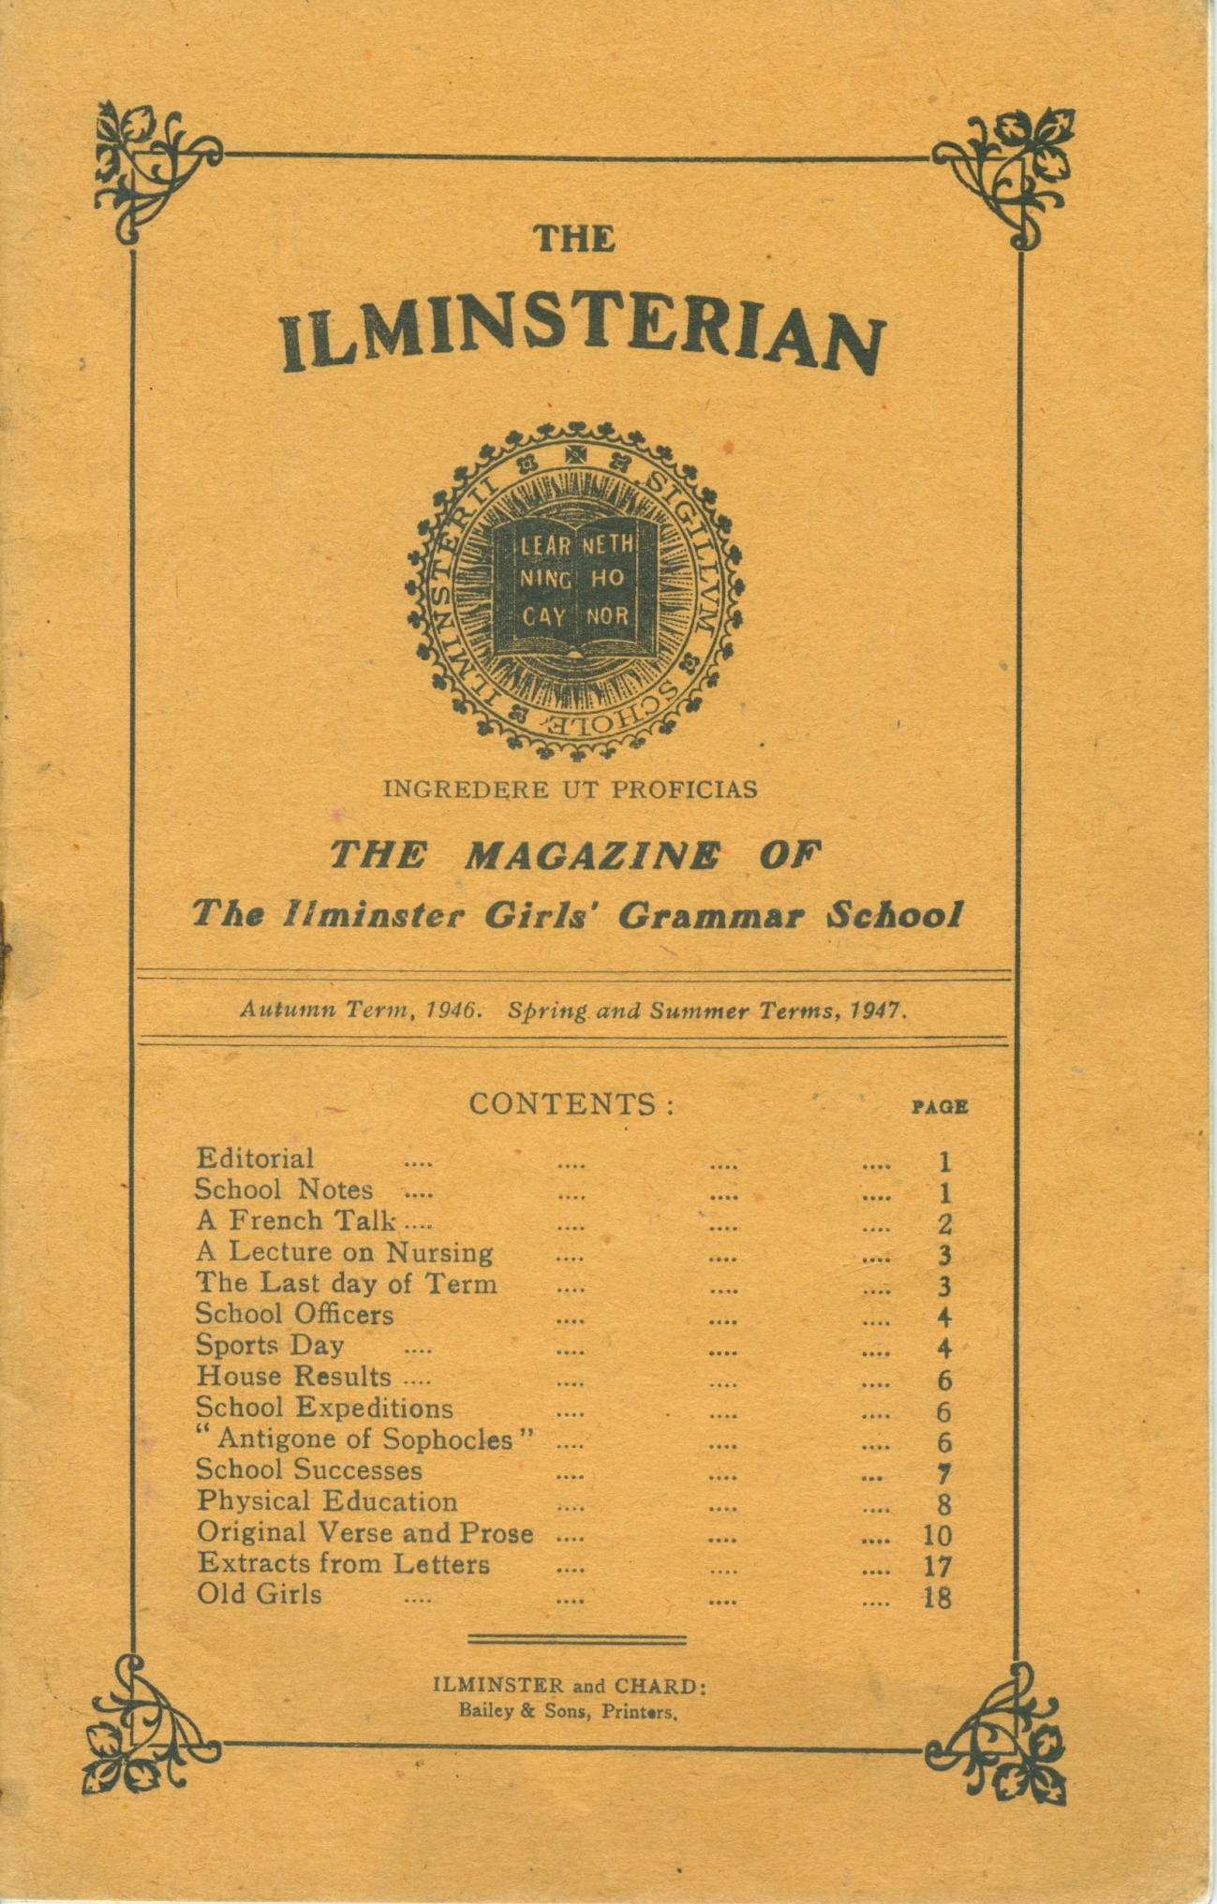

Contents – continued overleaf

**THE ILMINSTERIAN**

Autumn Term, 1946, Spring and Summer Terms, 1947

EDITORIAL.

It has been a great pleasure to us to be linked with a school in France - the College Moderne of Mussidan. Now that Miss Earl has actually been there we feel the link is very real. She told us of the friendly welcome she received and of the pleasant picnic she had in the "parc" with some of the mistresses and girls of the School. We, too, want to see the lovely country of Dordogne and to get to know the kind and charming people who live there. We also hope that girls from Mussidan will be able to get over to England to visit us.

SCHOOL NOTES.

Three new mistresses joined the Staff, Miss Scott to teach Latin and French, Miss Balsdon to teach Mathematics and Miss Ashton to teach Biology. Miss Scott, helped by Miss Langford, undertook gymnasium and games, and as seen in a full report on page made it a successful and beneficial part of school life.

Owing to abnormal weather conditions it was impossible to organise many expeditions or matches. The Autumn Term was a time of heavy rain, gales and floods, to be followed in the Spring Term by six weeks of severe frost and deep snow.

One Saturday in October a School party went to the Corfield Hall at Taunton to see " Macbeth " acted by the West of England Repertory Company. Lady Macbeth's acting was outstanding and the drunken porter caused amusement. It is a great help to girls who read and study Shakespeare's plays to attend these performances and we hope they will become a regular feature.

On November 6th Dr. Wallace lectured on the geographical and geological background to pre-historic times. Dr. Wallace had an interested and appreciative audience.

Form **Va** gave two Christmas parties in the afternoons of December 16th and 17th and as usual they were very jolly functions. The guests had to work hard at various competitions and round games and refreshments were provided in the interval. Both parties were well organised, and **Va**, helped by Miss Dolling, were delightful hostesses.

On the last morning of term, December 19th, the Carol Service with Tableaux was held by kind permission of the Vicar in the Church. It was a beautiful and reverent performance. The curtain rose on the Annunciation scene whilst a passage from St. Luke's Gospel was read. The School then sang "A Virgin most pure," followed by solos between Joseph and Mary. During the carol "Shepherds why do ye tarry," shepherds slowly made their way up the aisle and took their places in the Chancel with the Holy Family. Similarly, the three Kings took their places to the singing of "Three Kings from Persia." They were joined by a group of small children singing "How far is it to Bethlehem?" and the choir responded. The children knelt by the Crib and sang "The Rocking Carol." June Nuttycombe, the Head Girl, read all the passages from the Gospels between the carols, and all in the Church sang the concluding carol "O come all ye faithful."

We were very sorry to say good-bye to Mrs. Davis, who worked so wholeheartedly for the School, but we are delighted that she now has a little daughter and her own home.

Miss Nicholas, who held a commission in the A.T.S., joined the Staff on her demobilisation to teach French.

The School was closed on January 3oth and 31st owing to heavy snow- storms and we were unable to go to Church on Ash Wednesday, February 19th, owing to the severe weather and lack of heating in the Church.

On the last day of term Laureen Pearson gave a very entertaining talk on folk songs. She told the School about folk songs of different countries and how they came to be written and passed down from one generation to another. She made particular mention of Somerset songs and some of the songs were sung afterwards by the choir.

At the end of the Spring Term the Sixth Form and Old Girls presented a concert to the School in the gymnasium. The Old Girls taking part were: Mrs. Coles, Josephine Ashman, Peggy Scott, Pamela Scott, Mary Dolman, Peggy Shires, Ruth Bailey and Christine Coombs.

The performance opened with a one-act play "Catherine Parr," Henry VIII and Catherine played respectively by Josephine Ashman and Peggy Scott.

A song written by the Sixth Form was sung to the tune of "John Peel" ; the words had special reference to the various forms! The Old Girls made a very colourful group as " hillbillies " and their singing was accompanied by Peggy Shire playing the accordion. The final act was a play, " The Minister Directs " (produced by Miss Earl), in which a school staff was taught by the Sixth Form. This play had many references to our own School and gave the girls much enjoyment!

The Third Form acted "The Three Bears " and " Red Riding Hood " in French. They appeared in costume and, coached by Miss Nicholas and Miss Ashton, gave a very creditable performance.

The weather in the Summer Term was kind and we had long spells of sunshine and cloudless days. One exception, however, was on Saturday, June 14th, when a party to Low Ham was almost washed away and had to spend most of the time in the 'bus. The second pilgrimage there, organised by Miss Dolling, is fully reported on another page.

A FRENCH TALK.

On May 5th the School listened to a very interesting talk about France given by Madame Dêbu Bridel. She told us of the wonderful work of the French Resistance and how the French children lived in the time of the German occupation and how brave they were; how people would tear pieces of paper into the shape of a V for victory, and how two daring girls took a pair of scissors and cut pieces out of Germans' coats. The Jews, she said, were treated badly; they were made to wear a bright yellow star with Jew written in black across it. The Germans did not close the schools but they took all the books away and no heating was allowed. Therefore, the children had to sit in freezing rooms and do oral work. Lessons in French schools last longer than the lessons in English schools. The holidays are also different. The children have one week at Easter and Christmas and three months in the summer.

Madame Dêbu Bridel is the English mistress in a big school in Paris. She brought a party of girls and boys to London in the Easter holidays.

All the girls enjoyed the talk and liked the photographs of France which were passed round after the talk.

On the afternoon of May 14th, Mr. Barton (late Head Master of Bristol Grammar School) lectured on architecture and showed many slides. We hope Mr. Barton will visit the School again.

A full report of the School Play, which was given on the evenings of May 19th and loth, will be found in another part of this Magazine.

Two nurses, Miss Morley and Miss Burley, gave a talk on nursing to Forms **VI**, **Va** and **Vb** on May 28th.

A LECTURE ON NURSING.

Miss Burley began by describing nursing as it was about a hundred years ago. She illustrated her account with an extract from Dickens' "Martin Chuzzlewit", which describes the methods used by Nurse Gamp. Then Miss Burley continued with a dialogue between Lord Palmerston and Florence Nightingale on the eve of her career. Florence wanted the latter's opinion on nursing as a profession for women.

To explain clearly to us the conditions and routine of hospital life, both Miss Burley and Miss Morley contrived to get everything into a short sketch. Miss Burley represented a girl who had just left school wanting to become a nurse, and she asked all the questions such a girl might ask. Miss Morley, as the Matron, answered all the questions fully. Finally, Miss Morley answered many questions put to her by various girls.

Many girls showed their interest in the subject and maybe the lecture will have some influence on quite a number of girls when they leave school.

The terminal examinations were held as usual during the School Certificate fortnight at the beginning of July. After these were safely over the School looked forward to **Vb**'s concert and they were not disappointed as it is a tradition in the School to put on a good programme.

The programme included pianoforte solos, duets, a plantation scene with Negro songs and spirituals, and songs and choruses in costume from "The Mikado".

The sketch "Meet Mrs. Becton" was thoroughly enjoyed by all. Good acting supported by attractive period costumes and a liberal supply of food made us for the time being, forget these days of points and problems. The collection, which amounted to £4 2s. 0d, was sent to the Cancer Research Fund and St. Dunstan's.

The form was helped by Miss Dolling and Miss Langford.

THE LAST DAY OF TERM

On July 26th we broke up from School for the summer holidays. The last day of term is always very interesting. First the Third Form acted a scene from Shakespeare's "The Merchant of Venice." Sylvia Board, as Shylock, was excellent.

Then the Fourth Form performed some scenes from "Henry V".

Margaret Radford made a very good Katharine and Moira Chard was very good as Alice. After break each form sang one or two songs which they had learned during the term.

During the last week of the Summer Term the Sixth Form gave the rest of the School a lecture on the Law Courts of our land and how justice is administered.

June Nuttycombe gave a summary of the history of law from early times to the present day. Laureen Pearson described the working of Petty Sessions and spoke about the work of the justices of the Peace. Nora Small gave an account of the Assize and Highest Courts and how they work.

To show how a typical case would be tried before an Assize Court, the whole of the Sixth Form acted a play in which a young girl accused of forgery was tried. Witnesses were brought forward and the jury, which was composed of the Staff and a few members of **Va** were asked to return their verdict.

Miss Nicholas left to be married. She is sharing her brother's house at Wembury at present and is teaching in Plymouth. We offer her our warmest wishes for a very happy married life.

We had to say good-bye to Miss Pym, who has taught Art to the Senior School for many years. We are grateful to her for the loan of some of her own paintings to the School and we shall miss her weekly visits to Ilminster.

SCHOOL OFFICERS, 1946-1947

Head Girl: June Nuttycombe

Captain of Hockey: Mollie Jeffery.

Captain of Tennis: Mollie Jeffery.

House Captains:

Blake, Nora Small and Cynthia Clements.

Hanning, Barbara Swann.

Speke, Peggy Appleby and Daphne Thomas.

Walrond, Laureen Pearson and Molly Rowswell.

Prefects:

Peggy Appleby, Cynthia Clements, Gladys Gillard and Madeleine Grave (Autumn Term), Mollie Jeffery, Margaret Jenkins (Autumn Term), June Nuttycombe, Laureen Pearson, Molly Rowswell, Nora Small, Barbara Swann, Daphne Thomas.

Head of the Boarding House: Peggy Appleby

SPORTS DAY

On June 3oth, on the Playing Fields, the Vicar of Chard (the Rev. J. Vernon Twigg) presented the annual prizes and also acted as starter in the Sports which followed. Miss Earl welcomed Mr. Twigg and Mollie Jeffery, in the absence of June Nuttycombe, the Head Girl, gave him a book token with the best wishes of the School. After a short talk to the girls, when he pointed out the value of courtesy and good manners in the making of a useful citizen, the races began. Miss Scott had arranged an excellent programme and many parents and friends of the School enjoyed watching the events. Blake House gained the most points.

House Relay: Junior: 1, Walrond; 2, Speke; 3, Blake.

Middle 1, Blake ; 2, Harming ; 3, Walrond.

Senior-1, Blake ; 2, Speke ; 3, Walrond.

Final House Totals: I, Blake, 102 points ; 2, Walrond, 92, ; 3, Speke, 57 ; 4, Harming, 43

HOUSE RESULTS, 1946-47

|  |  |  |  |  |
| --- | --- | --- | --- | --- |
|  | Blake | Hanning | Speke | Walrond |
| Savings | 6 | 15 | 48 | 9 |
| Savers | 28 | 14 | 33 | 39 |
| Stars | 104 | 40 | 40 | 20 |
| Team members | 18 | 9 | 21 | 33 |
| Sports | 34 | 13 | 14 | 30 |
| Tiarks prize | 32 | 3 | 14 | 10 |
| Examinations | 7 | 1 | 5 | 3 |

Final Results: Speke: 171; Blake: 162, Walrond: 146,; Harming: 92

SCHOOL EXPEDITIONS.

**The Roman Villa at Low Ham**

July 26th a party of girls from Forms **II** and **IIa** with some friends went to see the remains of the Roman villa at Low Ham.

The villa is very capacious and is thought to have had about 7o rooms ; the room with the mosaic floor is very intriguing. This floor is of a very rare type, because most tessellated pavements are geometric patterns. The colours are now faded, red, blue, pale yellow and grey. No-one knows what they must have been like in their prime.

The pictures in the mosaic tell the story of the journey Peneas made to Carthage, and how he fell in love with Dido, the Carthaginian Queen, when Venus, who was jealous of Dido, thought of a plot for Cupid to carry out and poor Dido was killed.

t the far end of this unique cold room is the plunge bath which is separated from the cold room by a narrow passage. Unfortunately the bath has not been uncovered this year, so we did not see it. A little to the right is the hot room, showing the pillars of the hypocaust and the furnace beyond.

We also were very interested in the remains of the kitchen, where ashes and even oyster shells have been found. On one side of the fire the bricks were still blackened.

In the tent Mr. Dewar was piecing together a piece of mosaic which he showed us ; it resembled a fish.

After having a good look at the ruins we went to Mrs. Daly's, where we ate our lunch and afterwards played two games: hunt the treasure and searching for wild flowers in the field behind. At three o'clock we returned home after an extremely enjoyable time. Anne Bishop, **II**.

OLD GIRLS.

During the past year the Association reached a membership of 53 and it is hoped that all of these will continue membership and all new members will be welcomed.

We held a dance at Ilminster in November, but unfortunately it was not a great success. A "Novelty Quiz" with the School was very enjoyable.

A number of Old Girls were very pleased to take part in the School Concert at Easter, and the Association is very grateful to the School, who gave the collection of £4 towards our funds.' In April we had a Social at Ilminster when there was quite a large gathering of Old Girls who certainly enjoyed meeting old school friends again.

A hockey match with the School had been arranged, but unfortunately the weather prevented it being played.

This year we co-operated with the Old Boys in organising a Tennis Tournament.

We do hope that girls who are leaviing the School will seriously think of joining the O.G.A. as it is one way of keeping in touch with school friends.

*Transcribed from a copy of ‘The Ilminsterian’,*

*- provided by Jessica Danks, grand-daughter of Elaine Briault*

*mwp, 19/06/24*