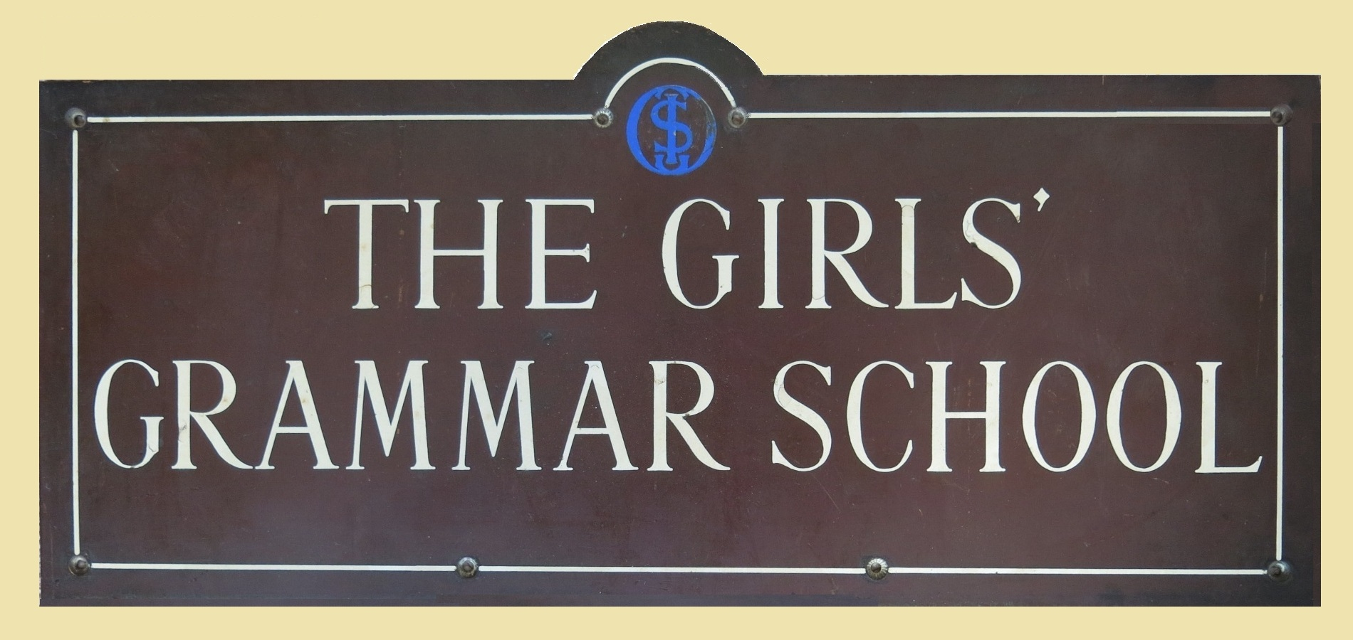
Address for Church Service 70th Anniversary Celebration 2015

The original Old Girls' Association was started in 1909 and continued, with a break during the First World War, until 1939, when activities were interrupted once again by war. Then on 2nd of May 1945 the group was revived. This is the report from that meeting.
"A gathering of approximately 50 one-time pupils of the Ilminster Girls' Grammar School was held in the schoolroom by kind permission of Miss Earl, Headmistress, and unanimously decided to form an Old Girls' Association. Officers were immediately elected as follows:
Chairman Miss H Taylor, Treasurer Miss S J Benham and Secretary Miss C M M Wainwright. It was proposed that Miss Earl be asked to become President of the Association, and that Dr R A Lowe, a Governor of the school, and Miss E E Wiggell, a former mistress of the school, should be asked to accept the Vice Presidencies.
The yearly subscription of 3/- was agreed upon with a copy of the school magazine to be included in this subscription.
A decision that future meetings should be advertised in the Chard & Ilminster News and the Western Gazette was accepted. The next meeting was arranged for July 4th, 1945, at 7.30pm."
It's interesting to be able to note some similarities and differences in comparison with today. Firstly, we have read that in 1945 a former mistress became a Vice-president. More recently Nancie Beale had become our President in 2008. No-one held the title of Vice President, although several ex-staff members were regularly attending our reunions. We were delighted when they accepted our invitation to become Vice Presidents, with full member status, and we are pleased to have Tony Reed and Roger Swann with us today. Another similarity is that instead of a school magazine, we now circulate our bi-annual newsletter. Finally a notable difference - we certainly have no need to advertise in a newspaper as we keep in touch with over 150 members, 74 of these by e-mail!
But back to 1945, when In subsequent meetings the committee wasted no time in appointing sub-committees to plan and oversee various activities, including tennis, hockey, cycling and social evenings. There were proposals to join the Old Boys' Association to form a joint concert party. Quizzes were arranged and teams chosen. During 1946 suggestions for future events included a dinner, a garden party, a dance and debates!
Reading through the interesting accounts of the newly formed Association, it seemed that the members were joyously embracing the new life, free from the uncertainties and worries of the war years. In 1949 an account was opened at Lloyds Bank, and the subscription of 3/- no longer included the school magazine, for which a further 2/- would be required!
In the 1950s a comprehensive list of activities continued to be arranged, including theatre visits. But for the most part meetings and activities could take place in school, using the facilities. The Annual Dinner during the 1950s was held in the George Hotel.
A presentation was arranged in April 1954 for Miss Earl's forthcoming retirement. This took place at the Annual Dinner and the gifts to Miss Earl from the Old Girls' Association were an electric fire, a travelling clock and a bouquet of gladioli and roses. In the same year the annual subscription rose from 3/- to 5/-, with the 5 year subscription rising from 12/6 to £1. However to encourage girls just leaving school to join, it was decided to keep the sub to 3/- for the first two years.
In 1958 Miss Ripley and Miss Wallis both left the school and were presented with picture tokens from the Association. Miss Hatfield, the new Headmistress was duly welcomed and became President.
There was a suggestion in 1970 that the Old Girls should amalgamate with the Old Boys' Association. However it was a unanimous decision for the Old Girls' Association to keep its separate identity and to continue to function as long as sufficient interest was shown. Attendances at the AGM had been dwindling so it was suggested that the AGM should follow the Annual Dinner in 1974. This boosted numbers considerably! It's worth noting here that in recent years, in spite of keeping our separate identities, we have enjoyed the company of committee members of the Old Ilminsterians as our guests, and our officers have attended their annual reunions. Today we are pleased to welcome Jeff Davies, Peter Rosewell and Bryan Neath and their wives, who are all joining our celebration.
In 1979 a special AGM and buffet meal took place in The Shrubbery Hotel, after a church service in the Minster, to celebrate the centenary of the founding of the Girls' Grammar School in 1879. The Chairman's remarks were as follows:
"About 200 were expected but we had 500 present. It was difficult to move in Ilminster for women!" (I know, I remember standing in the long queue outside the Shrubbery waiting to get in).
In 1980 it was suggested that lunch on a Saturday might be the way forward, instead of a dinner. Over the years many discussions took place and other formats were tried until we eventually settled on the arrangement we have today - two lunches, one in Spring and one in Autumn followed by a short AGM. Regretfully other activities have been dropped, partly due to the school premises no longer being available and also that many Old Girls have moved too far away to attend functions regularly.
However we have been active in another way and since 1996 our association has made many charitable donations, supporting fifteen different charities, both local and abroad, and contributing to four churches - in Ilminster, Donyatt, Barrington and Broadway. Over those years we have donated the grand total of £3,539, an incredible sum due entirely to the generosity of our members.
Our regular reunions have been interspersed with a few more memorable occasions. In 1995 we celebrated the 50th Anniversary of the reforming of our association with a service here in the Minster, where it was marked with the presentation of a specially commissioned English Oak flower pedestal to be used in the church and which we have arranged to use today. Lunch was held at Swanmead School and it was noted that membership had grown to 165. The 60th Anniversary celebration in 2005 was held at Broadway Church, with lunch in the village hall. Between these events we celebrated the new Millennium with a service at Donyatt church, again followed by lunch.
It has been fascinating to read the committee meeting minutes through the years from 1945 in order to compile this report. My friends in Weston-Super-Mare and beyond are amazed that the Old Girls' Association should continue to thrive long after the school itself has sadly closed. It speaks volumes for our dedication and gratitude to Ilminster Girls' Grammar School and the education we were privileged to enjoy. Today we celebrate 70 years of our Association and look forward with anticipation to our 80th Anniversary!

~~~

